**AWS Advanced Projects (Day13 – Day14)**

**========================================**

**Working with RDS:**

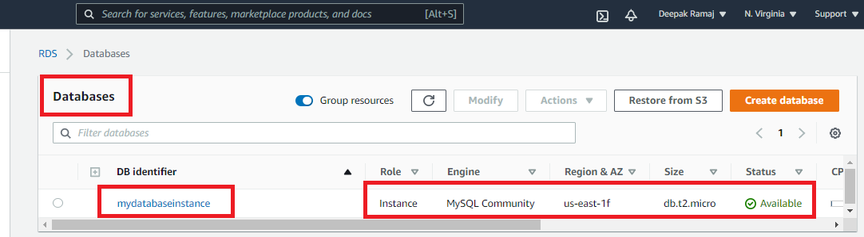

Fig. 1 Database instance

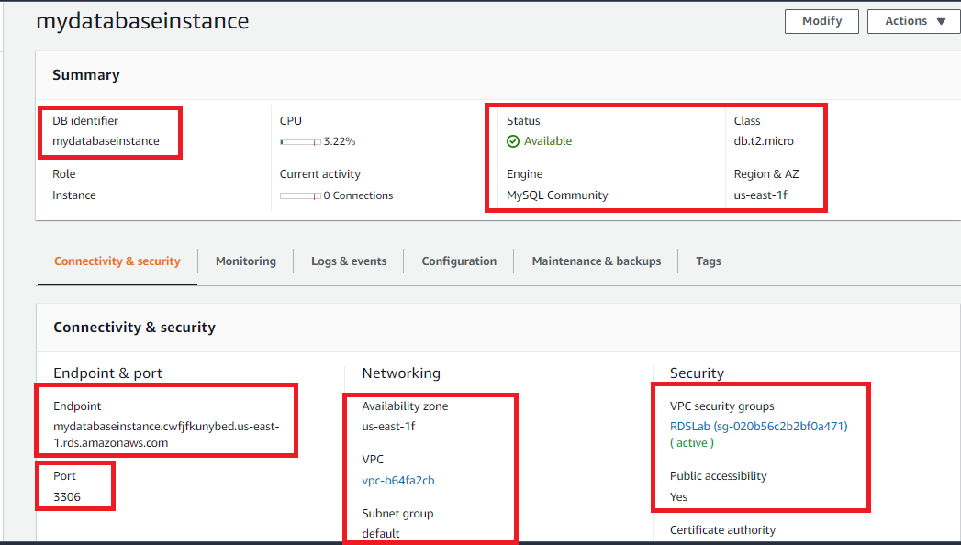

Fig. 2 Database instance details

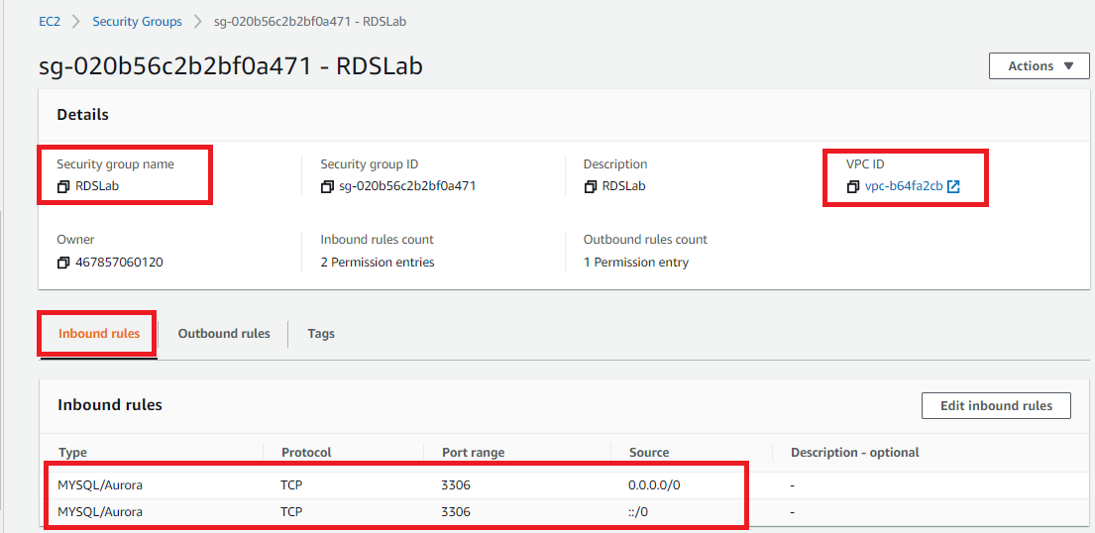

Fig. 3 Security group inbound rules

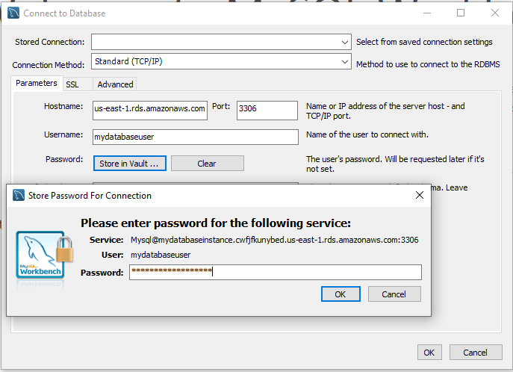

Fig. 4 mysql workbench added with security vault entry

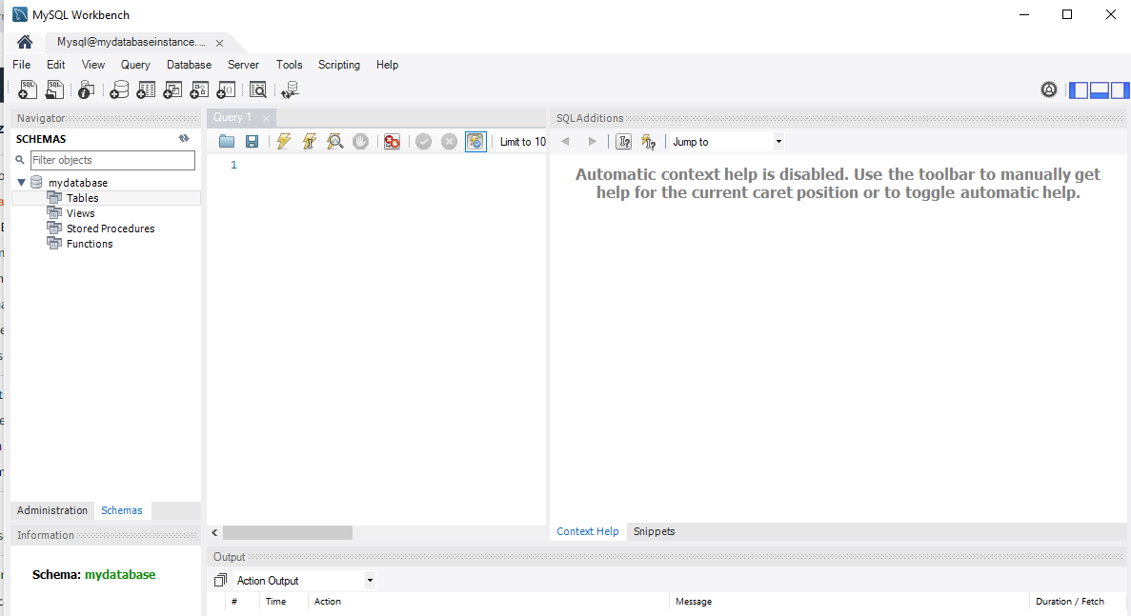

Fig. 5 connectivity screen